AIM-To perform Numerical Integration using Trapezoidal rule.

THEORY-
The trapezoidal rule is a numerical method that approximates the value of a definite integral. We consider the definite integral

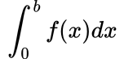

We assume that f(x) is continnous on [a, b] and we divide [a, b] into n subintervals of equal length
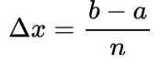

using the n+1 points

We can compute the value of f(x) at these points.

We approximate the integral by using n trapezoids formed by using straight line segments between the points (x_{i-1}, y_{i-1})and (x_{i}, y_{i}) for 1≤i≤n as shown in the figure below.

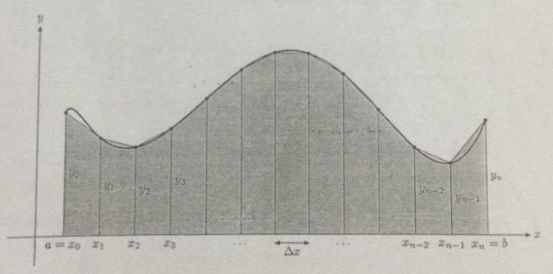

The area of a trapezoid is obtained by adding the area of a rectangle and a triangle.

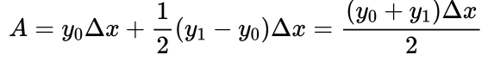

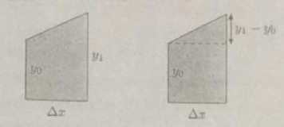

By adding the area of the n trapezoids, we obtain the approximation
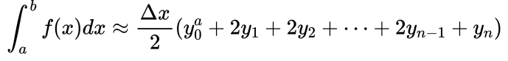

which simplifies to the trapezoidal rule formula.

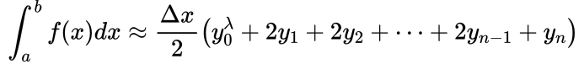

ALGORITHM-
1. Given a function f(x):
2. (Get user inputs)
Input
a,b=endpoints of interval
n=number of intervals
(Do the integration)
3. Set h= (b-a)/n.
4. Set sum=0.
5. Begin For i= 1 to n-1
Set x =a + h*i.
Set sum=sum+2*f(x)
6. Set sum = sum + f(a)+f(b)
7. Set ans = sum*h/2.
8. End

CODE-
#include<iostream>
#include<math.h>
using namespace std;
float func(float x)
{
float a;
a=sqrt(1+pow(x,2));
return a;
}
int main()
{
int n,i;
float a,b,h,sum,integral;
cout<<"\n Enter the upper limit: ";
cin>>a;
cout<<"\n Enter the lower limit: ";
cin>>b;
cout<<"\n Enter the interval: ";
cin>>n;
h=(a-b)/n;
sum=func(a)+func(b);
i=2;
while(i<=n)
{
sum=sum+2*func(b+(i-1)*h);
i++;
}
integral=h*sum/2;
cout<<"\n the answer is "<<integral<<"\n\n";
return 0;
}

OUTPUT-

